# Python Web Basics Exam Evaluation

## Exam in the Judge System

You will be given a **link** to the **contest** in the judge system. In the contest you will find only **one problem**. It will contain the **problem description** and a **skeleton**

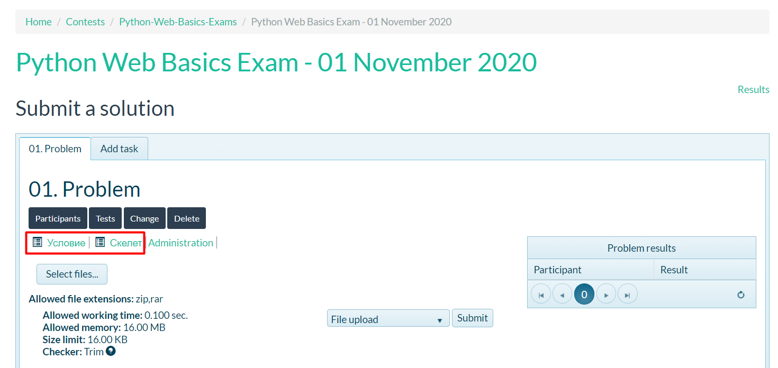

### Problem Description

There will be separate **sections** in the problem description as shown in the picture below. You should use **PostgreSQL** as database!

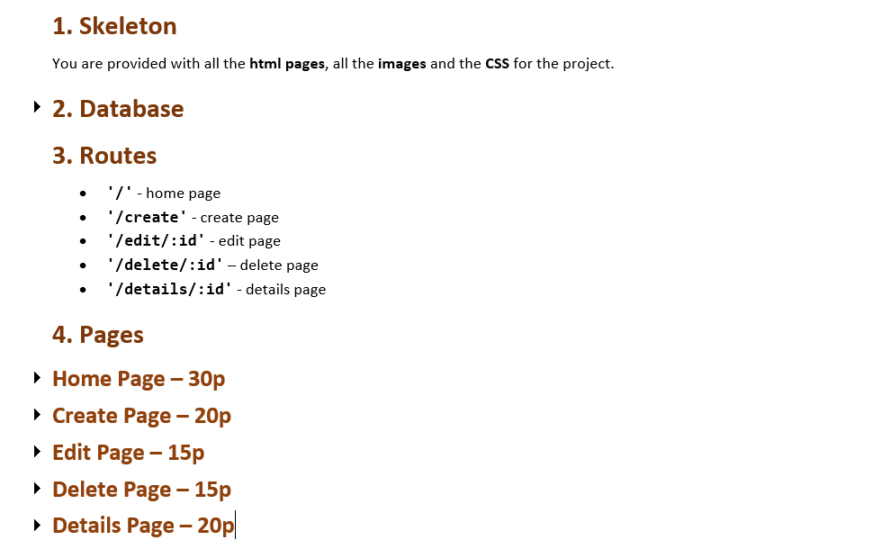

Each **page** will give you **points** which you can see in the title of the section. The points depend on how you display the pages (if all the **data** is **displayed correctly** with the **correct information**).

### Skeleton

The skeleton will include all the **html pages** which you will have to **split into templates** and the **css/images** that you will need.

## Judge Upload

Once you have completed the project, you have to **archive it** (zip format) and **upload** it in the contest

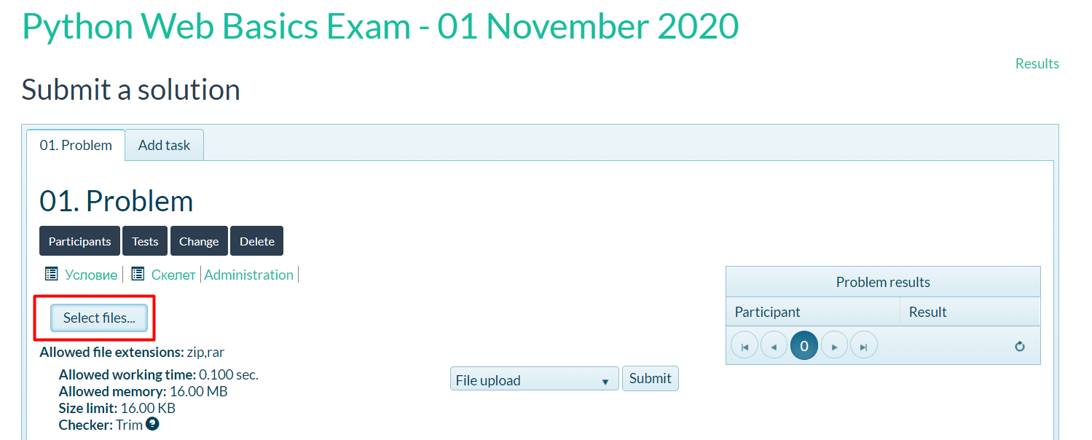

You don't need to **export your database**. The person evaluating your project will make sure that they create the database **before** they run your project.

## Evaluation

The evaluation is **NOT automated**. It will be evaluated **manually**. The results will be available **3-7 workdays** after the day of the exam. The evaluation will be done based on the **functionality** of the application (you are allowed to use any **additional Django tools** that you know).

## Support

In case of any **unclarities** or **questions**, the team will be available in the **sli.do** channel (**#python-web**) **during the exam**.